Class: Physics II, Dates: Lab performed 2/15/2023
Lab3: Introduction to Electrostatics
by

Sukaenah & Yarlin

Abstract

- Objective: Introduction to energy forms

- Introduction:

Quantity measurements of electrostatic charge can be challenging but, we like the challenges! Today we will explore those many factors that enter the buildup of electrostatic charge and our ability to measure the charge. For it we use “The Charge Sensor” is a very sensitive device that can detect charge on objects where you may not expect to see it like your body. Keeping in mind that electrostatics studies are difficult in humid environments because objects discharge quickly, we will perform this experiment at room temperature to obtain the best results.

- Apparatus and Materials:

Faraday Pail (aluminum can)
Ground Plane (flat metal sheet)
Cage (metal wire cage)
Grounding Wrist Strap
(2) Grounding Wires
Square of wool (fabric)
(2) Charge Separators
Square of vinyl (plastic pad)
Proof Plane
PVC rod
Cotton cloth
Nylon rod (white)

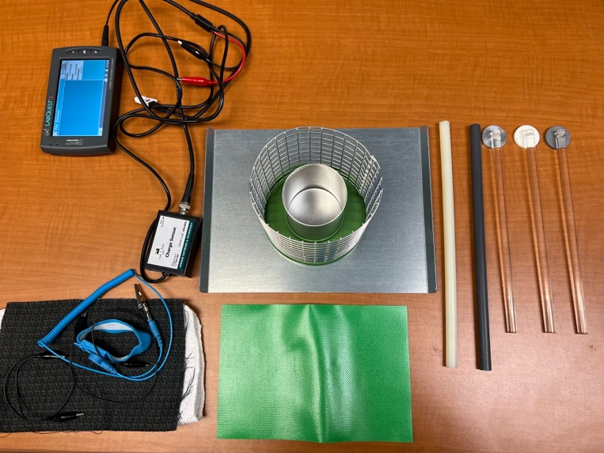

4. Procedure and Results:

The electrostatic kit allowed us to perform this experiment.

- Place the plastic disk that holds the Faraday pail and cage on the Ground Plane.
- Place the Faraday Pail and the Cage on the disc.
- Connect the black lead from the Cage on the disc.
- Connect the Charge Sensor to an interface.
- Connect a Grounding Wire between the Cage and the Ground Plate.
- Connect the Grounding Wire between the Cage and the Ground Plane.
- Ground the system and zero the sensor by pressing and holding the Reset button on the sensor.
- Insert an object into the center of the Faraday Pail. While the object is in the pail, the Charge Sensor displays the charge.

6. Conclusions
The charge on the Charge Separator is positive. When it is inside the Pail, the sensor showed a positive charge or 5.1. When the Pail is grounded, negative charge from the grounding is attached to the pail leaving the pail negative. These negative and positive charges cancel, and the sensor reads zero. Then with the grey Charge Separator is negative. When is inside the Pail, the sensor showed a negative charge of -5.1. When Pail is grounded, negative charge on the pail is repelled to the grounding plane leaving the Pail positive. These positive and negative charges cancelled, and the sensor reads zero.

7. Question:
Consider changes in temperature of water from 10ºC while it is cooled down to -10ºC: show schematically on a graph and explain.

With a cooler temperature, static electricity is higher because of the drier air.

