Class: Physics I, Dates: Lab performed 1/18/2023
Lab 4: Newton’s Third Law
by
Ambryn Andrews Rebecca K.
Abstract
The materials that were used in this project include: a rubber band, a 30 cm strand of polka-dotted tape, and a roll of stainless steel wire (.001). The goal of this experiment is to measure the amount of force value of the rubber band and ribbon without breaking while the amount of force it takes to break the stainless steel wire. Observe each object for changes in the quality of the material when force is applied such as elasticity and elongation.

2. Introduction

1. According to the Newton’s third law force acting on a body causes equal reaction force acting in the opposite direction. To observe this in experiment, two force sensors will be used. The force sensors are connected directly or via a rubber string, plastic tape, or a fine steel wire. Force is applied to one force sensor and the reaction force is measured with another force sensor. This experiment allows also to measure strength and ductility characteristics of the material:

Stress=Force/Area: σ=F/A
Elongation=Final length-Initial length/Initial length x 100% : ε=(L_{f} – L₀)/ L₀ *100%

- Apparatus and Materials: Two Vernier Dual-Range Force Sensors, stainless steel wire, rubber band, plastic polka-dotted tape, LabQuest Mini data acquisition box (plug in the LabQuest Mini to the USB port on the computer and the motion sensor into the LabQuest Mini) (Fig. 1). Ruler.

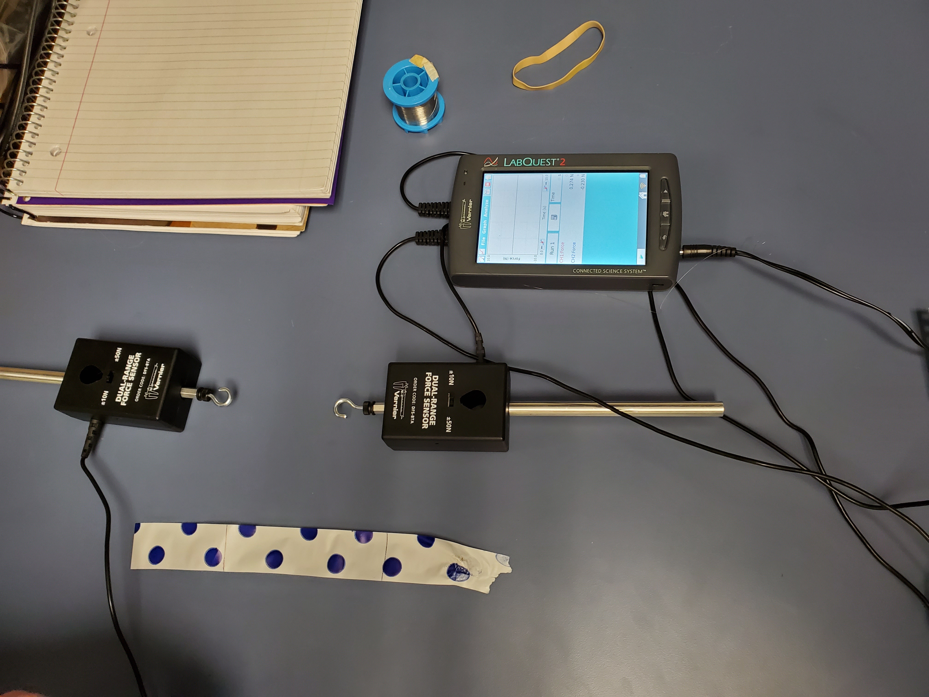

Figure 1. Experiment equipment

Motion

sensor
4. Procedure and Results:

1. Ribbon- Initial measurement: 30 cm
Final measurement after stretch: 33 cm ( reason for the short stretch was the ribbon broke)

E= l-l0/l0x100%= 33cm-30cm/30cmx100= 0.1x100%= 10%

2. Rubber Band- Initial measurement: 2 cm with a force of 0.13N
Final measurement after stretch: 13 cm with a force of 13.220N

3. Metal wire- force to break it: 2.967N

@= F/A= 2.967/2mm(0.05mm)=2.967/0.1= 29.67 mP

5. Analysis & Summary:
In this experiment, we analyze Newton’s third law: For every action, there is an equal and opposite reaction. Using 3 different materials we tested the strength and elongation using Force sensors. These trials were able to prove that the force being used on each end of objects are equal, proving Newton’s third law.

Observations: I noticed during this experiment that we pulled the ribbon too quickly causing it to break. If we had slowly pulled the ribbon we would have had a larger number for our elongation. With the rubber band I noticed that more force caused it to slightly tear which caused an issue for the following group causing them to use a different material for their force measurement. In doing so their data will be different because instead of a rubber band which has more stretch they used a hair tie. With the metal wire I observed that it was thin and difficult to tie which caused it to be more slippery. This caused an issue to where we had to hold the metal wire end in order to measure the force it took to break it.

Takeaways:
-Don’t rush pulling the ribbon because it will break.
-Being sure to have enough wire to tie onto the hooks to ensure they wouldn’t slip off
-Experimental error includes: The small measurement of the ribbon is because it wasn’t pulled slowly causing it to break instead of reaching the maximum stretch. Weight on the table for the sensor to measure force for the rubber band. The metal wire slipping off of the hook.

- Question:

If the ribbon was slowly stretched instead of quickly would the data be different? Why?

Yes. The data would be different because the length would increase which in turn would change the percentage of elongation. Slowly stretching the ribbon ensures the elongation to be larger than quickly stretching it because when you quickly stretch you are putting more force on the ribbon quicker than if you would slowly pull it.

