Class: Physics I, Dates: Lab performed 1/25/2023
Lab 5: Introduction to Energy Conservation Law
by
Ambryn A. Rebecca K.
Abstract
We observed rolling of a ping pong ball from an inclined ramp to a flat surface. We measured an average speed of the car on the flat surface which was v_{exp}= 0.71 m/s. We also estimated the ping pong ball average speed from the Low of Energy Conservation as v_{theor}=sqrt(2gh) which was 0.67 m/s and was close to the experimentally measured value. This provides support to the Low of Energy Conservation in this simple mechanical system.

1. Objective: Introduction to Energy Conservation Law
2. Introduction: According to the Energy Conservation Law, a sum of Potential energy, PE=mgh, and Kinetic energy, KE=mv²/2 is constant. The potential energy at the top of the inclined is the highest and KE=0 because the car is stationary. At the base of the incline, PE=0: all energy was transformed in KE: mgh = mv²/2 that yields v=sqrt(2gh).
3. Apparatus and Materials: Ping Pong ball, Phone timer, Ramp, Ruler, Paper, Pencil

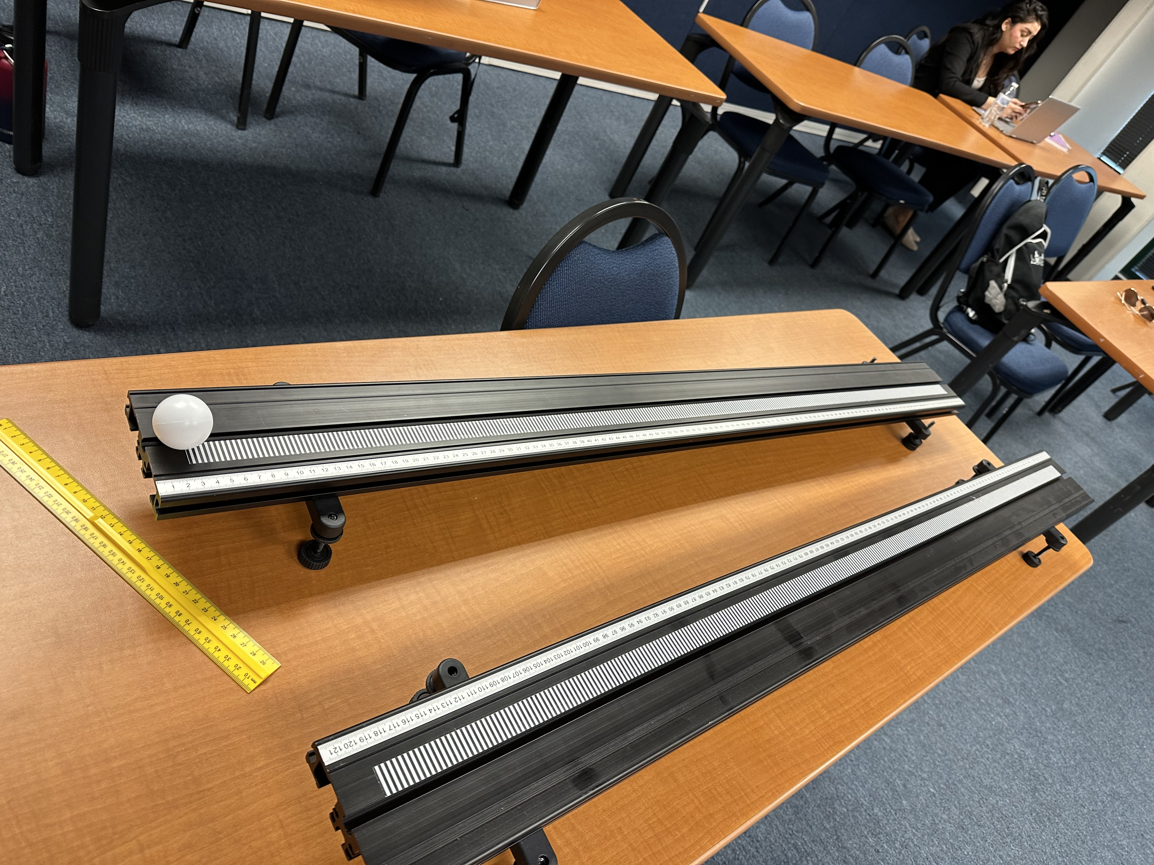
4. Procedure: i. Measure the height of the incline, ii. determine speed at the bottom of incline, iii. compare it with the theoretical speed calculated according to v=sqrt(2gh).
5. Results & Discussion. The height was: 8.4cm which I converted to 0.084m. The height with the support was 6.1cm which then was converted to 0.061m. The length of the incline was 130cm which was converted to 1.3m.
h0= 8.4 cm (0.084m)
hs= 6.1 cm (0.061m)
L= 130cm (1.3m)
t1= 4.33s
t2= 3.18s
t3= 3.65
Equations used:
V= L/t1= 1.3m/4.33s= 0.30m/s; V2= 2 L/t= 2(0.30m/s)= 0.60 m/s
V= L/t2= 1.3m/3.18s= 0.41m/s; V2= 2 L/t= 2 (0.41m/s)= 0.82m/s
V= L/t3= 1.3m/3.65s= 0.36m/s; V2= 2 L/t= 2(0.36m/s)= 0.72m/s
In order to find the expected velocity we had to take the original height and subtract it from the support height.
h= h0-hs= 0.084m-0.061m= 0.023m
Vavg= V1+V2+V3/3= 0.60+0.82+0.72/3= 0.71m/s
Vexp= sqrt 2hg= sqrt 2(0.023m)(9.8m/s2)= 0.67m/s
The statistical error is the standard deviation of the velocity of the ping pong ball. Our statistical error was 0.08m/s.
St dev.= sqrt (V1-avg V)sq + (V2-avg V)sq + (V3-avg V)sq/2= sqrt (0.6-0.71)sq + (0.82-0.71)sq + (0.72-0.71)sq/2 = 0.08m/s
Vmeas= Avg V +/- st dev= 0.71 +/- 0.08 m/s
The experimental error is related to measurement of length. The percent of error, e, was calculated as: e=0.5mm/61mm *100%, where 0.82% was the percent of error in the measurement of the ramp.
6. Conclusions. Experimental speed was 0.60 m/s, 0.82m/s, and 0.72 m/s and theoretical speed was 0.67 m/s which are relatively close that confirms the Energy Conservation Law.
7. Question. What would you suggest to increase the accuracy of this experiment?
I would suggest that only one person uses the timer and ensures that they start at the same point every time. I would also suggest that the person just barely holds the ball then releases to ensure that they do not push the ball creating more force and energy than the previous times. Also another way to increase accuracy of the experiment is that you stop the timer at the same point every time because that can create a variation in your numbers.

