Class: Physics II, Dates: Lab performed 2/1/2022
Lab 7: Force Equilibrium
By:
Ambryn A Rebecca K.
Abstract

1. Objective: Introduction to Statics
2. Introduction: This lab is designed to measure the amount of Force it takes to equalize the amount of washers at the 30 degree angle and the 60 degree angle.
3. Apparatus and Materials: Force table, weights, pulley, pencil, paper, cellphone

Experimental set up
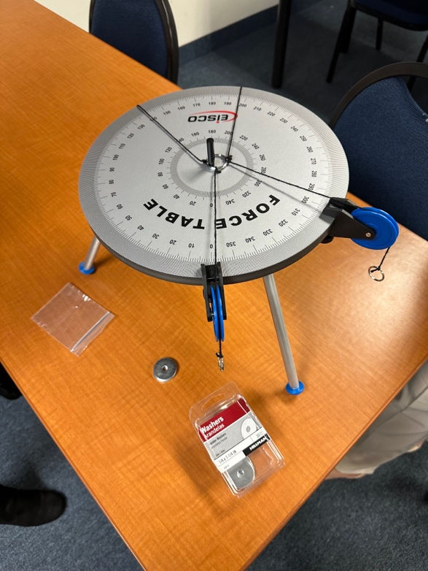

4. Procedure: We moved the 2 pulleys to equal a 30 degree angle with the 3rd pulley on the opposite side to equal out the distribution of weight. During this part we had to add the washers on each side to ensure that the weight was evenly distributed to center the ring around the pole. The next measurement was to move the 2 pulleys to equal a 60 degree angle with the 3rd pulley on the opposite side to equal out the distribution of weight. During this part we added the washers on each side to distribute the weight to center the ring around the center of the pole.
5. Results & Discussion. First up was the 30 degree angle. With the equations used below. We included pictures to show the weight distribution.
Σ=Fx=0
Σ=Fy=0
Mg(sin theta)-mg(sin theta)=0
Mg(cos theta)+mg(cos theta)=T=m3g
2n(cos theta)=n3
2(5)(0..87)=n3=8.7 about 9
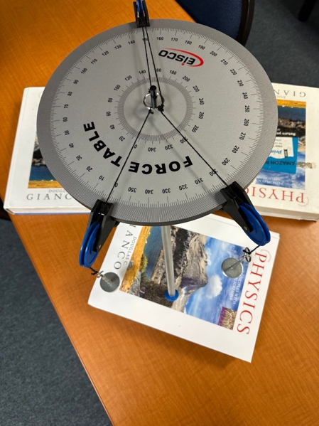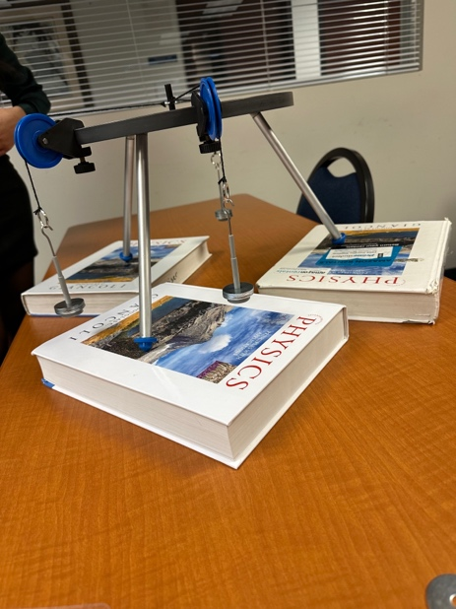
During this part of the experiment with the pulleys put at 30 degrees we noted that the initial two had 5 washers while the 3rd pulley had 9 to equal out the weight to ensure the weight was evenly distributed as seen in the images above. When we plugged in the numbers to the above formula (2n cos theta=n3). 2n cos 30=n3 which equaled 8.7 which was then rounded up to 9 as you can’t use 0.7 of a washer during this experiment. This experiment shows that the 9 washers was correct to evenly distribute the weight of the 5 washers on pulley 1 and 2.

Next we moved the pulleys to the 60 degree angle to measure how many washers on pulley 1, 2, and 3 were needed to distribute the weight evenly.
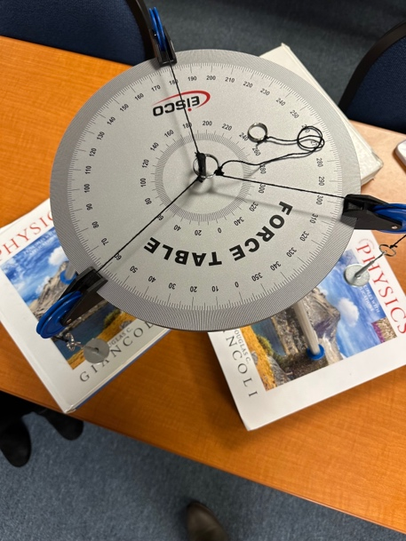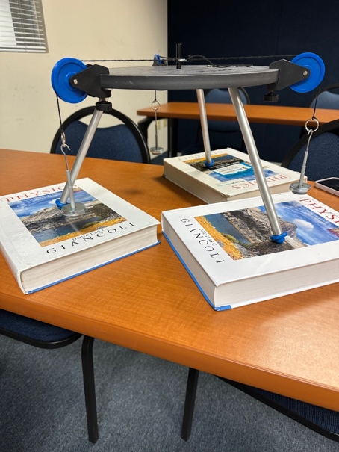
We used the same equation of 2n(cos theta)=n3 for the 60 degree angle as well. Instead of inserting 30 in the theta position we put cos 60 (2n cos 60=n3) to give us the amount of washers needed on all 3 pulleys. By inputting the 60 we noted that in order to create the equal distribution of weight 5 washers had to be put on pulley 1,2, and 3. As seen in the pictures above.
6. Conclusions.
This experiment showed us that at different angles the amount of washers were different. We discussed that it was interesting to see that at a smaller angle pulley 3 needed more washers to evenly distribute the amount of weight between all 3 pulleys. We also discussed that the amount of washers needed to balance the pulleys at 60 degrees was 5 washers on all 3 pulleys which was also surprising to us. We both thought that at the smaller angle the washers would be even all the way around instead of more on one side. We noted that this experiment showed us that the weight distribution is different for all angles.
7. Question.
Why do you think that the smaller angle needed more washers to have an even distribution?
I think that the smaller angle needed more washers to have an even distribution was because the component of the tension along the axis increases.

