Class: Physics II, Dates: Lab performed 2/2/2022
Lab 8: Force Equilibrium Pt. 2
By:
Ambryn A. Rebecca K.
Abstract

1. Objective: Introduction to Statics
2. Introduction: This lab measures the Torque it takes to equalize the weight of the box at the end of the ruler with the force applied on the other end. The equation that was used to measure our numbers was F2=F1x L1/L2.
3. Apparatus and Materials: Desk, ruler, boxes, force measurer, pencil, paper, cellphone
Picture below shows experimental setup
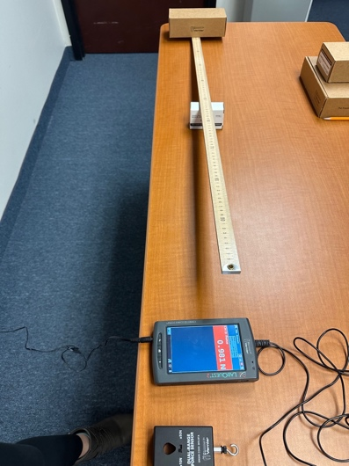
4. Procedure: The ruler was set at 0.75 m (with a box underneath) with the weighted box placed on one end of the ruler while on the other end we used the force meter to push down to measure the force it takes to equalize both ends. Then the ruler was placed at 0.50 m (with a box underneath) with the weighted box placed on one end of the ruler while on the other end we used the force meter to push down to measure the force it takes to equalize both ends. After completing both measurements we wrote down our numbers to plug into our equation.
5. Results & Discussion.
The given equation:
F2=F1x L1/L2
We know our mass and distances. We need to find the force.
Mass= 0.232kg
D1= 0.75m
D2= 0.50m
Fi= 0.975
Expected force for 0.50m= F=mg= 0.232kg (9.8 m/s2)= 2.27 N
Measured total force for 0.50m= 2.039 N
Expected force for 0.75m= EFx3= 2.27N x 3= 6.81 N
Measured total force for 0.75m= 8.828 N
The difference between our expected force and measured force for 0.50 m was 0.231 N. These two forces were very close. Now with our expected force and measured force for 0.75m the difference was 2.018 N which was higher than we expected.
6. Conclusions.
We discussed that the force would be lower with the ruler being placed exactly in the center and that more force would be needed when we moved the ruler to 0.75m. We calculated our actual force that it took to equalize the weight of the box and the ruler and noted that we were correct in our thinking of the amount of force we needed for the two different distances. We were surprised at how big the N difference was for our 0.75m measurement but realized that our meter was not set at 0 which skewed our measurements a bit.
7. Question.
Do you think our numbers would be closer if the meter was set a 0N?
Yes. I believe our numbers would be closer if the meter was set at 0N. I believe this because we would be able to get a more accurate read on the force it would take to equalize the weight of the box with the force on the other end.

