Class: Physics I, Dates: Lab performed 1/25/2021
Lab 6: Introduction to the Impulse Conservation Law
By
Rebecca K. Ambryn A.

Abstract
In this lab, a cart released on a track at a slight angle collides elastically with a bumper and velocity before, V₁, and after collision, V₂, is measured. As expected according to the linear momentum conservation law, we observed V₁ = - V₂. In this lab we had two balls 24 cm apart. One of the balls gets pushed forward to hit the other ball. We are trying to find the velocity of both balls.

Introduction
The momentum of an object is the product of its mass and velocity: P = mv, where P is momentum, m is mass, and v is velocity. Changing the momentum of an object requires force; the total force applied over time, called the impulse, is equal to the change of the momentum: FΔt = ΔP = Pf - Pi. In the event of an elastic collision, each object comes out of the collision in the same shape and mass with which it entered, and total momentum is conserved; the sum of the momentums of each object before the collision should be equal to the same sum after the collision. In an inelastic collision, some energy may be lost to noise, vibration, heat and/or deformation, or the objects may even stick together upon collision; if energy is lost in the collision, total momentum may not be conserved.

2. Materials
Figure 1. Materials used are track ramp, ping pong balls, video camera, and a ruler.
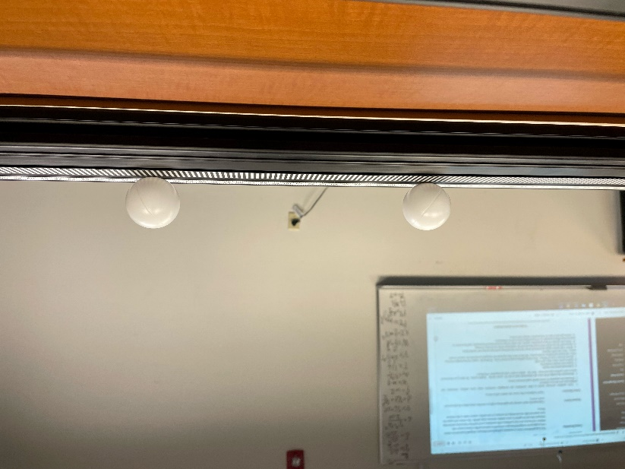

Procedure

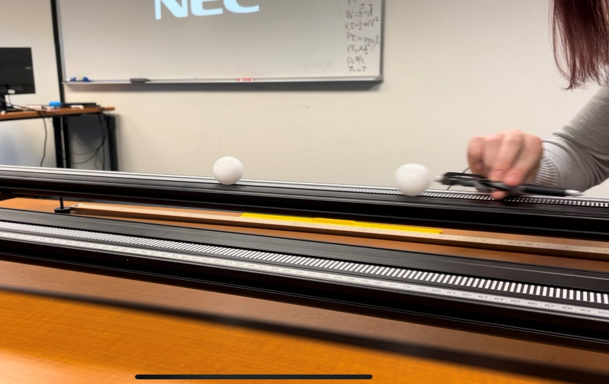
This is when we hit the first ball to collide with the second ball.
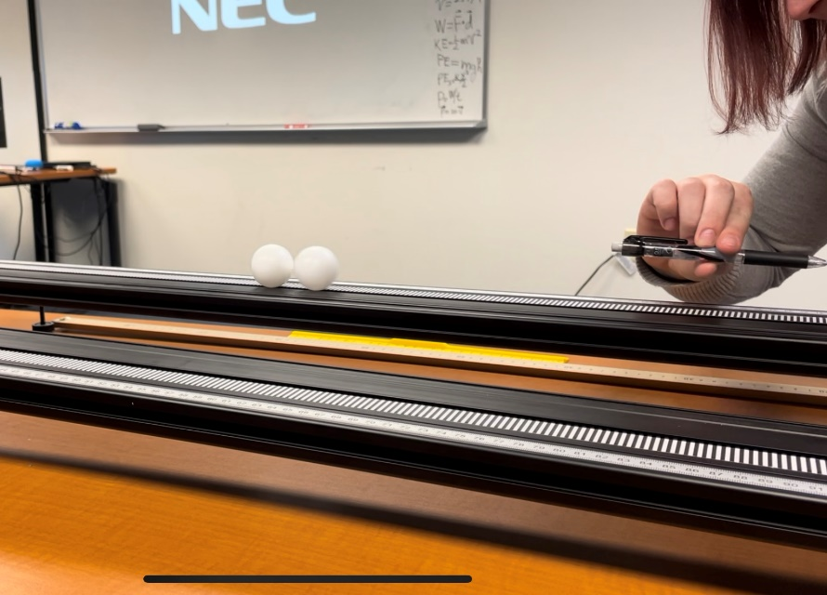
This is when both balls finally collide into each other.
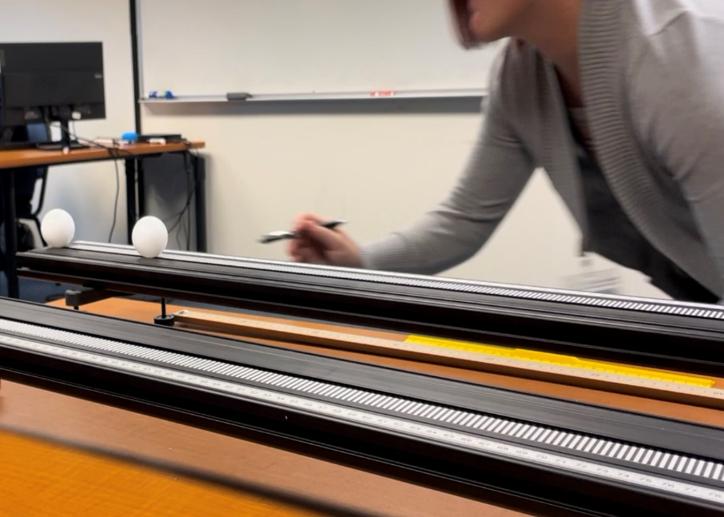
This is a few moments before the second ball fell off and the first ball followed right after.

1. we lined up both ping pongs to be 24cm apart, and then we used a pencil to push them. We push the first ball into the second ball. We measured the distance they were apart and the distance of the second ball when it fell off the ramp. We measured the time it took for the first ball to hit the second ball and we measured the time it took both balls to fall off the edge of the ramp. With both the times and distances we found the velocity of both balls.

4. Results and Analysis
m₁v₁=m₁v¹+m₂v₂¹
Before collision of both balls
V initial both balls= 0cm/s
D1=24cm T1=0.23s V=D/T 24cm/0.23s= V=104.3cm/s

After collision of both balls
D2=50cm T2=4.03s(2nd ball) V=D/T 50cm/4.03s= V=12.4cm/s
D2=50cm T3=5.38s(1st ball) V=D/T 50cm/5.38s= V=9.3cm/s

5. Conclusion
During this lab we expected the ball to hit the 2nd ball and stop transferring the momentum to the 2nd ball. Due to experimental error the 1st ball continued to roll behind the 2nd ball. We noticed that the first ball had a faster velocity because the momentum had increased while the 2nd ball had a slower velocity due to the momentum decreasing despite going the same distance and direction.
6. Question.
If the 2nd ball was twice the mass of the first ball what would the velocity of the 2nd ball be after the collision?
V= 2(D/T)= 2(50cm/4.03s)= 2(12.4cm/s)= 24.8cm/s

